**DAILY ONLINE ACTIVITIES SUMMARY**

|  |  |  |  |  |  |  |  |
| --- | --- | --- | --- | --- | --- | --- | --- |
| **Date:** | **30-06-2020** | | | | **Name:** | **B.A.SOHANKUMAR** | |
| **Sem & Sec** | **4TH SEM A** | | | | **USN:** | **4AL18CS013** | |
| **Online Test Summary** | | | | | | | |
| **Subject** | | **----** | | | | | |
| **Max. Marks** | | **----** | | **Score** | | **----** | |
| **Certification Course Summary** | | | | | | | |
| **Course** | **COMPUTER VISION ESSENTIALS** | | | | | | |
| **Certificate Provider** | | | **GLA** | **Duration** | | | **5 HOURS** |
| **Coding Challenges** | | | | | | | |
| **PROBLEM STATEMENT:1: C Program to check whether the number is Ugly or not.**  **PROBLEM STATEMENT:2:C++ program to move all zeros to end of the array using Two pointers.** | | | | | | | |
| **Status: EXECUTED** | | | | | | | |
| **Uploaded the report in Github** | | | | **YES** | | | |
| **If yes Repository name** | | | | **LOCKDOWN CODING** | | | |
| **Uploaded the report in slack** | | | | **YES** | | | |

**CERTIFICATION COURSE DETAILS:**

Course: Computer vision essentials

Completed modules today are CNN Architectures and LeNet Case Study,Case Study : AlexNet,Case study:ZFnet and VGGnet,Case Study : GoogleNet,Case Study : ResNet,GPU vs CPU.

 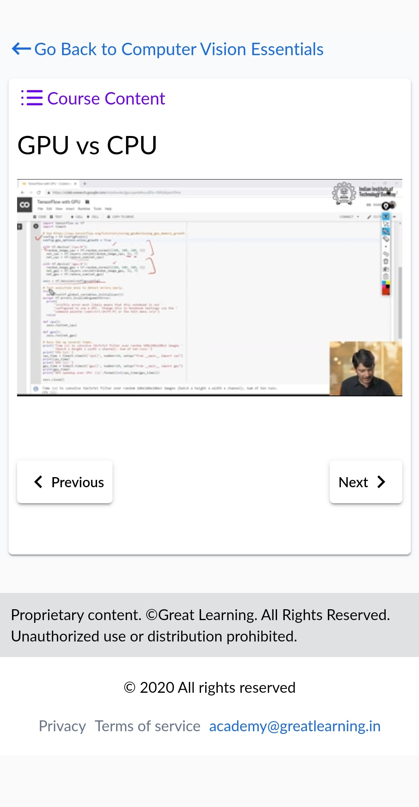

**CODING CHALLENGES DETAILS:**

1.Write a C Program to check whether the number is Ugly or not. Ugly numbers are those number whose prime factors are 2, 3 or 5. From 1 to 15, there are 11 ugly numbers 1, 2, 3, 4, 5, 6, 8, 9, 10, 12, 15. The numbers 7, 11, 13 are not ugly because they are prime. The number 14 is not ugly because in its prime factor the 7 will come.

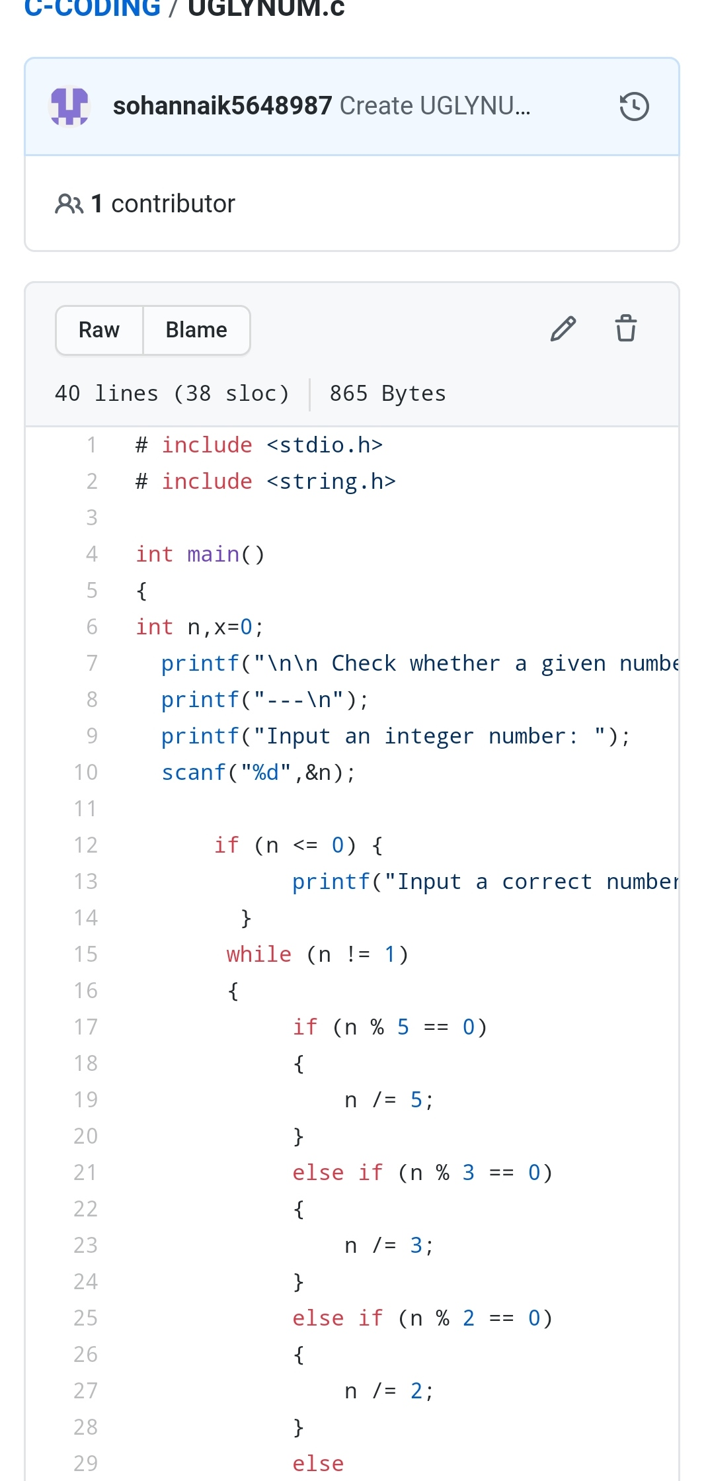

2.Write a C++ Program to Move all zeroes to end of array using Two-Pointers.Given an array of random numbers, Push all the zero’s of the given array to the end of the array. For example, if the given arrays is {1, 0, 2, 6, 0, 4}, it should be changed to {1, 2, 6, 4, 0, 0}. The order of all other elements should be the same.

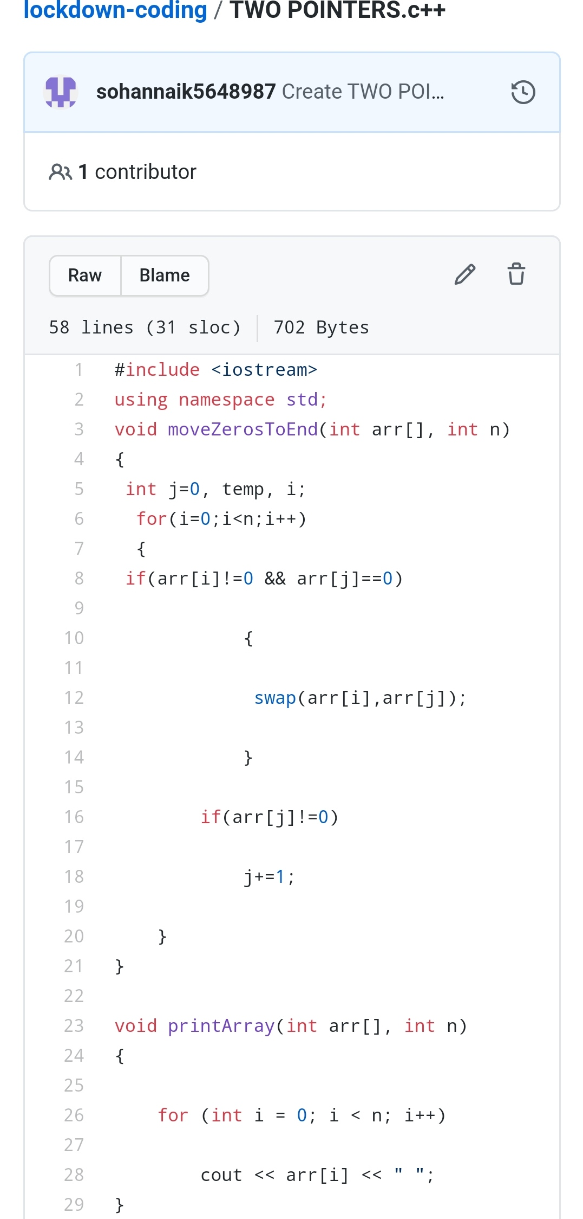

REPOSITORY LINK:https://github.com/sohannaik5648987/lockdown-coding

https://github.com/sohannaik5648987/C-CODING